1. 1. R = b\* a a\* b b\* a a\* b b\* + a a\* b a\* b => b\*aa\*b + aa\*b

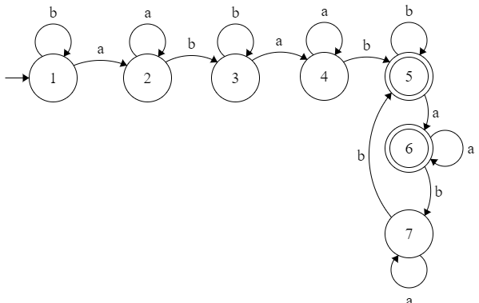

* 1. R = (aa + bb + (ab + ba)(aa + bb)\*(ab + ba))\*

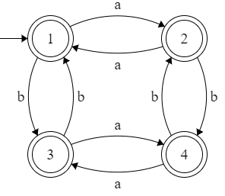

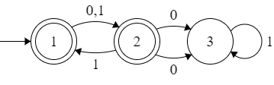

2. R = a + aa\*(a + b)a
3. Suppose there is a DFA=M for L(M)=rma(L) which is regular

Let n=k all states and rma(L) accepts all strings w

If the DFA for rma(L) accepts a word w then L accepts wa.

Since L accepts all w in rma(L) and an a, making its states n=k+1

Each word has only one extra a which is k+1 states over rma(L) k states